**3. Karachi Public School**

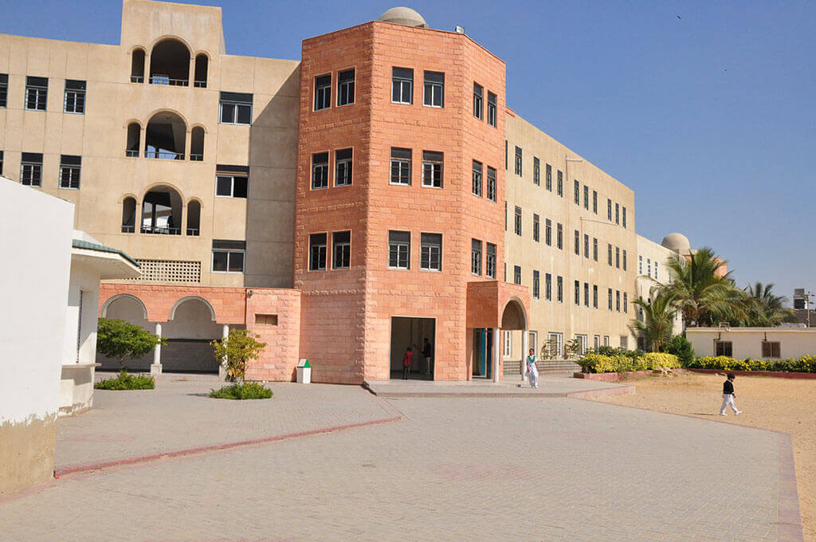

[**Karachi Public school**](https://kps.edu.pk/) (KPS) is another best school. This school was started in 1980 and still growing in strength, covering all grades from pre-nursery to [**O-levels**](https://ilmibook.com/o-level-in-pakistan/). It’s been 40 years and this school has had full success in creating an educational environment that polishes minds and converts them into the bright future of Pakistan. Their vision is not to get just good grades, but also on developing and achieving professional as well as personal skills. Other than curriculum, the environment and best staff of school engages students in extra-curriculum activities such as debates competition, quizzes, sports, etc. it has 5 campuses covering pre-nursery and nursery section, primary and secondary section.

**Admission Procedure:**

For admission to Karachi Public School, the registration form is available on the website of KPS [**here**](https://kps.edu.pk/register-my-child-now/). After submitting the registration form, you can visit a nearby branch to get further guidelines.

**Fees Structure:**

Karachi public school fees 2020-2021 are as follows.

|  |  |
| --- | --- |
| Admission Fee | 18,000 PKR |
| Monthly Fee (From Pre Nursery To Prep II) | 4,700 PKR |
| Monthly Fee (From Grade 1 To Grade 7) | 5,000 PKR |
| Other Charges (Annually) | 4,000 PKR |

**Affordability:**

Parents can actually now breathe a sigh of relief. With the ever-increasing cost of education, KPS is committed to providing high quality education that is affordable.

**Contact Details with campuses:**

1. **P.E.C.H.S Campus:**  Plot E, 80, Pakistan Employees Co-Operative Housing Society Block 6 PECHS, Karachi.
2. **Stargate Campus:** [Plot 80 E, Block-6 Block 6 PECHS, Karachi, Karachi City, Sindh, Pakistan](https://goo.gl/maps/EuaE1w3W1UHi3wJ89)
3. **Gulshan-e-Iqbal Campus:** [Olympian Islahuddin Rd, Block 6 Gulshan-e-Iqbal, Karachi, Karachi City, Sindh 75300, Pakistan](https://goo.gl/maps/3QcVdDGt1HjzCzmP7)
4. **Gulistan-e-Jauhar Campus:** [W4CG+4V9, Block 14 Gulistan-e-Johar, Karachi, Karachi City, Sindh, Pakistan](https://goo.gl/maps/3uregtsAd8B49XNX8)
5. **Korangi Campus**: [Plot No, 9, Altaf Town Sector 30/A Bhittai Colony Korangi Creek, Karachi, Karachi City, Sindh, Pakistan](https://goo.gl/maps/Xzt5XGfyst6iYWKP7)
6. **Malir Campus:**  [W6HV+8XP, Gadap Town, Karachi, Karachi City, Sindh, Pakistan](https://goo.gl/maps/MCELj9j4HtExrVXa9)

**Phone no:** [0333 032 5467](https://wa.me/923330325467)& [0317 289 3669](https://wa.me/923172893669)